Math 120 (5493), Mathematics for General Education (3 units)
Fall 2018 Syllabus
Instructor: Veli Hergul.
Email: veli.hergul@gcccd.edu
Lecture Hours: Monday/Wednesday, 08:00 – 09:15 am
Location: H-133
Office Hours: After each class.
Prerequisites: “C” or better in Math 103, Math 110, or equivalent.
Texts and References
- Required (representative example): Sobecki & Mercer. Math in our World: A Quantitative Reasoning Approach. McGraw-Hill, 2017.
- Supplemental: None

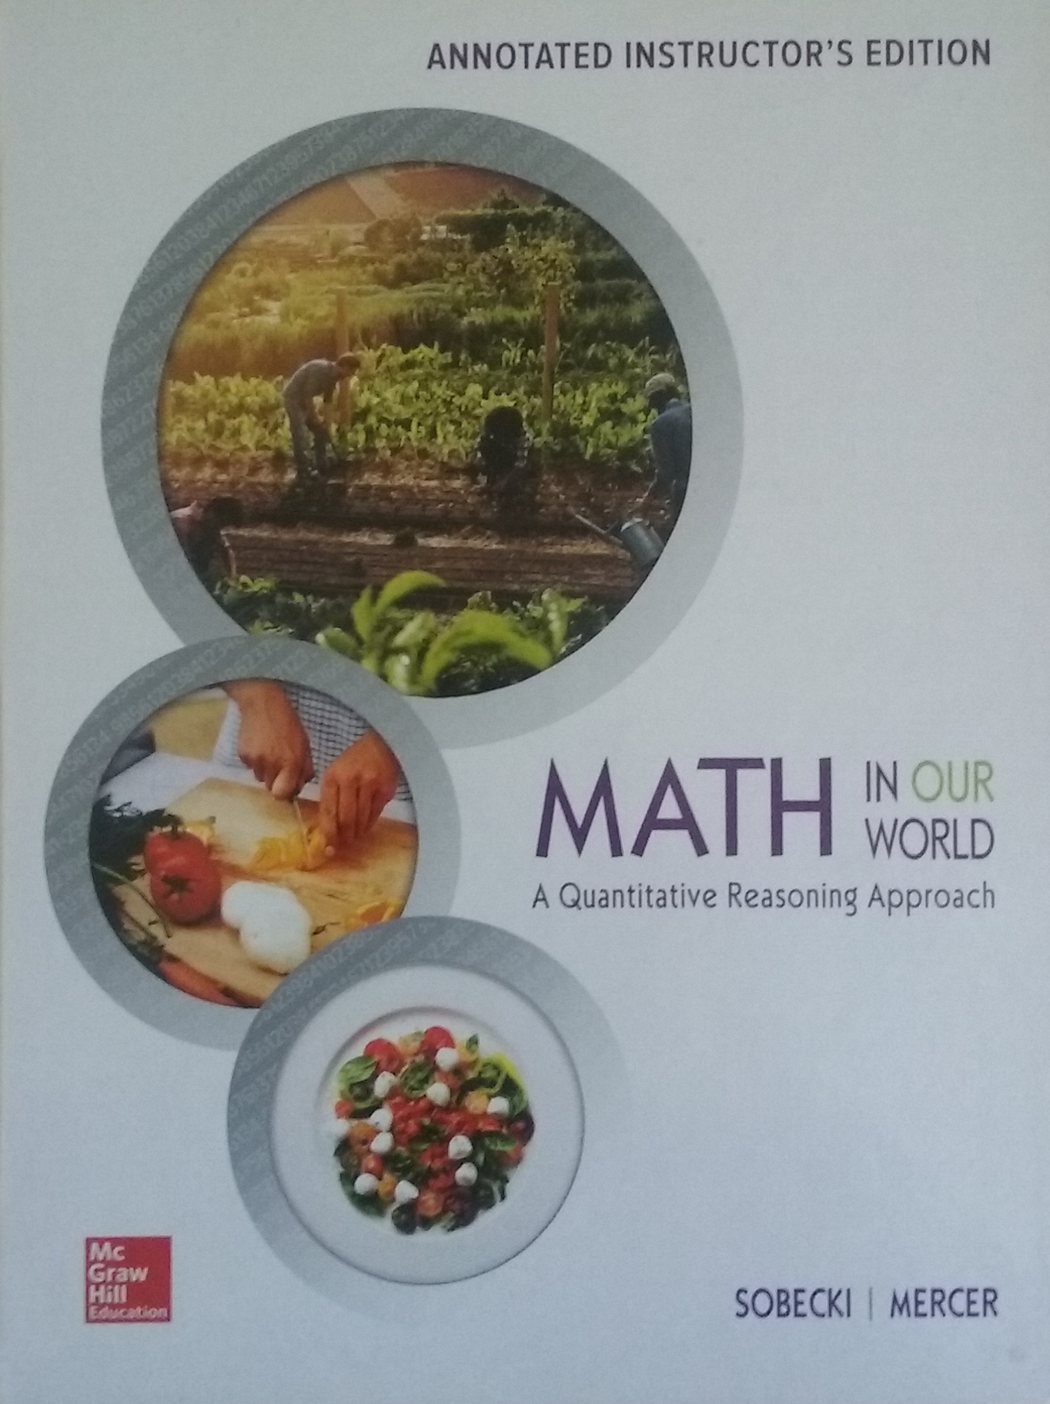
Calculator: A scientific calculator each class meeting. If you plan on taking Math 160 - Statistics, then a TI-83 or 84 is recommended.
Catalog Description
The students will survey the historical development of mathematics and apply topics such as logic, geometry, probability, statistics, problem solving, sequences and patterns, numeration systems, and personal finance to develop quantitative reasoning skills. Designed for students who do not intend to prepare for a career in science or business.
Entrance Skills
Without the following skills, competencies and/or knowledge, students entering this course will be highly unlikely to succeed:
- Understand basic mathematics vocabulary and terminology.
- Computing and simplifying using the basic operations on real numbers and algebraic expressions.
- Solve linear equations, quadratic equations, systems of equations and linear inequalities.
- Geometry: understand definitions of the basic shapes; familiarity with perimeter, area and volume.
- Graph linear and quadratic equations.

Course Content: 1) Logic (inductive vs. deductive reasoning)
2) Patterns and predictions from pattern recognition or formulas
3) Personal finance (may include budgeting, installment buying, investments, or student loans)
- Spatial Analysis (may include congruence and similarity, polygons, area and perimeter, or use of shapes)
- Diagrams, Figures, and Charts (may include truth tables, histograms, mapping, or Euler diagrams)
- Relevance of topics to mathematical applications and to current social issues
- General problem solving techniques as well as those specific to topical problems
- Historical context for survey topics

Course Objectives
Students will be able to:
- Utilize the concept of logic (inductive vs. deductive reasoning), set theory, and various problem-solving strategies to analyze problems and to formulate and carry out appropriate solution strategies.
- Identify and practice problem solving skills related to survey and historical topics.
- Apply logic and reasoning to problems based on life experiences or current events.
- Solve problems using diagrams, maps, graphs, and other geometric figures.
- Calculate and interpret quantities important for understanding probability, statistics, personal finance, or other survey topics.
- Analyze patterns in order to develop solutions, formulas, or predictions about survey concepts.
- Communicate reasons why solutions are correct or applicable, and the value of understanding a given survey topic.

Student Learning Outcomes
Upon successful completion of this course, students will be able to:
- Use reasoning techniques and problem solving strategies to categorize and solve a wide range of problems covered in a survey of mathematical topics.
Analyze patterns, and apply visualization and organizational techniques to a range of topics that can be applied to liberal arts courses and life experiences

Attendance: Attendance will be taken on a regular basis. You will have more success if you attend every class session. Each class session builds upon the work produced in the previous sessions, so regular attendance helps you succeed. If you exceed 3 absences, without an acceptable reason, it is considered excessive and you may be dropped from the course. However, do not assume you will be dropped from the course!! In the event of an absence, you are responsible for: • all material covered • turning all assignments in on time • any schedule changes or class announcements
Important College Dates:
Last Day to Drop without "W" (semester length classes) | 9-Feb
Last Day to Apply for Refund (semester length classes) | 9-Feb
Holidays: Lincoln’s & Washington’s birthdays / Memorial day | Feb 16, 17, 19 / May 28
Last Day to Apply for P/NP (semester length classes) | 2-Mar
Last Day to Apply for Fall 2017 Degree/Certificate | 9-Mar
Last Day to Drop Semester Length Classes | 27-Apr
Final Examinations / M120 Final | May 29 – June 4 / May 30, 08:00 – 10:00
Close of Fall Semester | 4-Jun
Instructor Grade Deadline | 7-Jun

Homework: HW will be “Application” portion of the book, and due on exam days.
Group Work: (This includes In-Class Group Work Activities, and Writing Assignments) – Students are expected to solve problems and work together with other students in groups on some special assignments and class work activities.
Exams: There will be four exams, 2 Regular exams, and 2 Midterms as they are shown in the schedule. No exam score will be dropped and there are no retakes. Exams will cover material from the lecture notes, homework problems, and chapter reviews. If you miss an exam, you will receive a zero for it. Make up exams may ONLY be taken by PRIOR ARRANGEMENT or in the case of a DOCUMENTED emergency and only if you contact me on or before the exam. No cell phones will be used on exams. To better help you plan accordingly for the semester the exam dates will not change.
Grades: • Group work/Homework = 15%, Project = 15%, Exams = 15% x 2, Midterms 20% x2 • A = (100 - 90%), B = (89.9 - 80%), C = (79.9 - 70%), D = (69.9 - 60%), F = (less than 60%) • No Incompletes will be given unless it meets the criteria stated in the college catalog and is approved by the Dean in consultation with the instructor.
Tutorial Services: To support your efforts to success in this class, it is highly recommended you utilize the FREE math tutoring services available in the STEM Center or the Tutoring Center. STEM Center Hours: M – Th 9a – 6p, F 9a – 2p. I strongly recommend tutoring for any student who is experiencing difficulty in grasping the concepts and staying current with the material. It is important that a student recognize and take action early in the semester before getting too far behind. Please know, however, that tutoring is not meant to be a substitute for doing the work. Before going to the Tutoring Center, a student should have already worked hard and attempted the material to be covered in the tutoring session.
DSP&S: Academic accommodations are available for students with disabilities. If you suspect that you have a disability, or require services for any other type of disability, please contact Disabled Student Programs & Services in the One Stop Center (A-113) or call at 619-660-4239
Classroom Guidelines: Class time is valuable. You are expected to be courteous to each other and to the instructor. You will be asked to leave the class for display of behavior the instructor deems as disruptive to the class environment. Take care of all business before you arrive to class. If you have to enter or leave the class while lecture is happening please do so quietly. Remember that YOU are in charge of your education, so take responsibility and do your best to learn the material. If you have a question, ask it. If you don’t understand something, say so!
Please turn off and put away your cell phones during class. Putting away your phone means that it is off your desk and away in your backpack. Therefore there is absolutely NO CELL PHONE USE, WEB SURFING or TEXTING allowed in class.
Misconduct: Cheating and plagiarism (using as one's own ideas writings, materials, or images of someone else without acknowledgement or permission) can result in any one of a variety of sanctions. Such penalties may range from an adjusted grade on the particular exam such as a score of zero for anyone engaging in cheating on any, paper, project, or assignment (all of which may lead to a failing grade in the course) to, under certain conditions, suspension or expulsion from a class, program or the college. For further clarification and information on these issues, please consult with me or contact the office of the Associate Dean of Student Affairs.
How to be Successful in this Class: ATTEND CLASS. The majority of students who do not complete this class are students that miss in excess of 2 class meetings. Feel free to ask questions any time during class. FORM A STUDY GROUP. Meet outside of class with 2 or 3 students on a regular basis and work on assignments. Exchange phone numbers and email address and stay in contact for help. USE THE TUTORS. The tutors in the Math Study Center are there to help you if you need it on a walk in basis. COMPLETE ALL ASSIGNMENTS. Complete your assignments by practicing a little bit each day. You can learn, develop skills, and retain concepts only with practice. MML has great resources to help learn the material. Explore the options and take advantage of them.
KEEP A POSITIVE ATTITUDE. Try to enjoy the calculus experience. Few people do well in something they hate.
Disciplinary Action Procedures: 1. When a student conduct violation has occurred, the first attempt to resolve the misconduct will be an informal consultation between the student and the instructor (or college staff member). 2. If the situation is unresolved, the Dean will meet with the instructor and the student(s) involved. 3. If the situation remains unresolved, the instructor will complete a “Report of Student Misconduct” and file the report with the Dean of Student Services. 4. In situations involving safety or if the College Police have become involved, steps 1 and 2 need not be adhered to.
Finally, by enrolling in this class you agree to all of the terms and conditions listed on this syllabus. Enjoy the class and if you have any questions feel free to contact me.

 | Cuyamaca Math 120 Spring 2018
 | Week of | M | T | W | Th
1 | 29-Jan | 1.1 |  | 1.2
2 | 5-Feb | 1.3 |  | 2.1 / 2.2
3 | 12-Feb | 2.3 / 2.4 |  | 2.5 - 2.8
4 | 19-Feb | Holiday |  | Exam 1
5 | 26-Feb | 3.1 |  | 3.2
6 | 5-Mar | 3.3 |  | 3.4
7 | 12-Mar | 4.1 |  | 4.2
8 | 19-Mar | Review |  | Midterm 1
9 | 26-Mar | Sp Brk | Sp Brk | Sp Brk | Sp Brk
10 | 2-Apr | 4.3 |  | 5.1
11 | 9-Apr | 5.2 |  | 5.3
12 | 16-Apr | 6.1 |  | 6.2
13 | 23-Apr | 6.3 / 6.4 |  | Exam 3
14 | 30-Apr | 7.1 |  | 7.2
15 | 7-May | 7.3 |  | 7.4
16 | 14-May | 8.1 |  | 8.2
17 | 21-May | Review |  | Midterm 2
18 | 28-May |  |  | Mterm 2 Corr.

On Exam Days: There are no bathroom breaks, so use the restroom prior to beginning the exam

Modifications May Occur Due to Unforeseen Circumstances

